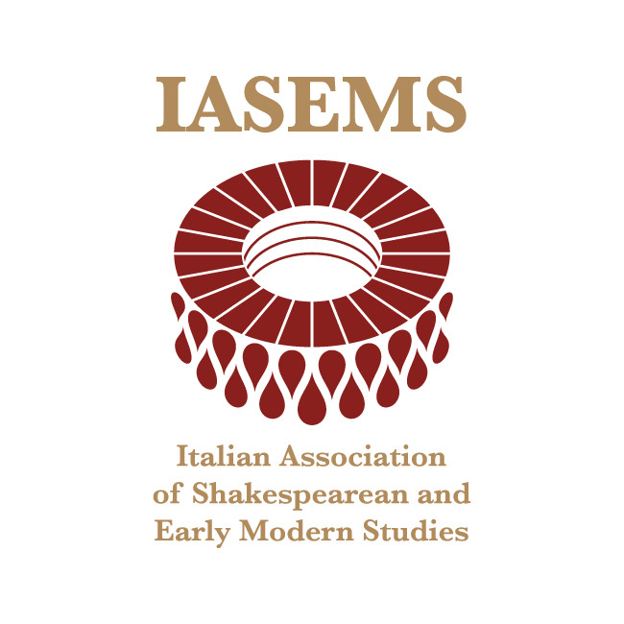

2025 BURSARIES
FOR JUNIOR IASEMS MEMBERS

The Italian Association of Shakespearean and Early Modern Studies is accepting applications for bursaries to support the participation of young members (i.e. PhD students and candidates, post-doctoral and research fellows within five years of the award of their PhD) in the Lecce IASEMS conference in May and in the graduate session of the Viterbo IASEMS Conference in September of this year.
IASEMS will fund 6 bursaries of up to 200 euros each.
Eligibility requirements:
1) applicants must be IASEMS members in good standing with the payment of the annual fee (20 euros for junior scholars);
2) applicants must have had a submission accepted at either the Lecce conference or the Viterbo graduate session;
3) applicants should not hold an academic position (lecturer, associate or full professor).
Applications – to be filled out using the form herewith attached – should be sent to info@iasems.org, along with a CV, a copy of a valid ID, and the abstract of the paper to be presented at the Conference or Graduate session by no later than 31 March 2025.
The same person may not apply for both the Viterbo graduate session and the Lecce conference and preference will be given to those who have not received a bursary in previous years.
Once completed applications are received, materials will be reviewed as soon as possible by the IASEMS Executive Board. All efforts will be made to provide a decision to the applicant within two weeks.
The bursaries will be paid after the Conference and based on the receipts (travel, meals, and accommodation) that should be submitted electronically at info@iasems.org within two weeks after the end of the conference.
The bursary recipients are expected to attend the whole conference.

The IASEMS Executive Board

I, …, born in … , on …, residing at …,

HEREBY REQUEST

to be admitted to the selection for 6 bursaries, each worth up to 200 euros, to support the participation of young IASEMS members in

o the IASEMS conference to be held in Lecce from May 16 to 17 2025
o the graduate session of the IASEMS conference in Viterbo from September 29 to 30 2025.

To this aim, I declare:

- to be a IASEMS member in good standing with the payment of the annual fee as of the date of signing this application;
- to have a submission accepted at … (title of paper: …);
- to not hold a permanent academic position as full professor, associate professor, or lecturer at any Italian or foreign university.

Please explain how you would profit from attending the conference/graduate session (explain your motivation, interest in the conference’s topics, and expected benefits. [max 500 words]

Place and date … Signature …

Please complete and return the completed application form and combine with supporting documents into a single PDF file.

